# **All about Google Cloud Ready Facilitator Program**

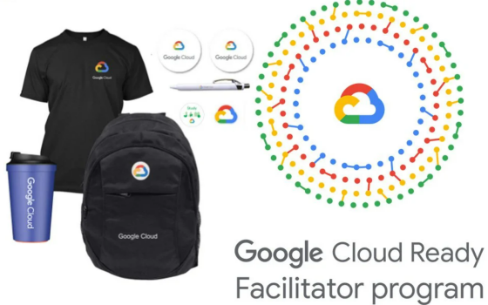

# ****_What is GoogleCloudReady Facilitator program?****

The GoogleCloudReady Facilitator program will provide you an opportunity to kickstart your career in cloud and get hands on practice on Google Cloud — the tool that powers apps like Google Search, Gmail and YouTube.

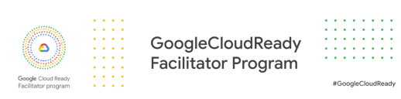

# **_Major Highlights of the program**

* Free Google goodies.
* Google badges.
* Google Cloud certification.
* Free access to google programs

# **_Why to participate in the program?**

* To get adequate and brief knowledge about different applications of google cloud and how to use them to enhance your career with the help of Google Cloud Facilitator Program.
* In the program you will learn cloud concepts, Application Development, Big Data And Machine Learning with multiple hands-on labs available. This program is one of the finest opportunity to kickstart your journey in Cloud.

# **_Who Should Attend?**

* All those who want to become an expert in Google Cloud and want to enhance your skills.
* All those who want to transform and accelerate their career in cloud domain.
* Any fresher or experienced person can join this program, learn multiple things and as a add on you will get cool swags from Google Cloud to showcase your learnings from the program.

# ****_Eligibility criteria for enrolling in the program?****

1. You need to have access to a working internet connection & a laptop with latest chrome browser.
2. You need to be above 18 years of age and enrolled in an higher education institution in India.
3. You need to be a student in the institutions selected by Google or must have been referred by any of the “Facilitators” that are part of the program.

# **_When do they conduct the program?**

* They do conduct this program every year in the month of April.
* For the next three months from April this program will be active and there you need to go through the various learnings tracks and complete the hands-on exercises on Qwiklabs to be eligible for the swags.
* There are multiple milestones that you need to complete to get the goodies. Bases on the count of milestones you have completed you will get the swags accordingly.

# **_What are the milestone? How many are there? Prizes?**

This program has been divided into total four major milestones and individually milestones have multiple learning tracks which consists of several Quests and Learning Badges consisting hands-on labs in it which you have to complete in Quiklabs and each milestone have their different Prizes.

To earn the prizes in this program you have to complete all the Quests in each milestones and get the skill badges.

Just Remeber!!

# **“THE HIGHER THE MILESTONES, THE HIGHER THE PRIZES”**

# **_About Milestones**

****Milestone 1 → Cloud Infrastructure Track****

In milestone 1 you need to complete any 10 quests and 5 skill badges in the program. As the reward for completing milestone1, you will be getting one google cloud t-shirt, Google cloud badge, Google cloud Pen, and Google cloud stickers.

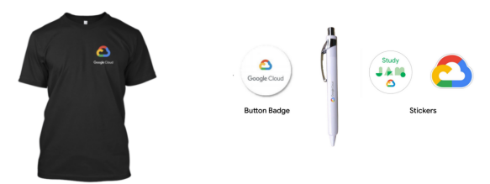

****Milestone 1 Prizes****

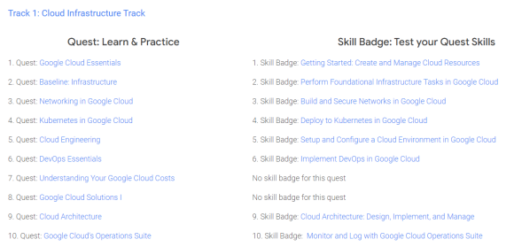

****Milestone 2 → Cloud-native Application Development Track****

In milestone 2 you need to complete any 20 quests and 10 skill badges in the program. As the reward for completing milestone 2, you will be getting one sling bag, a Google cloud t-shirt, a Google Cloud badge, Google cloud Pen, and Google cloud stickers.

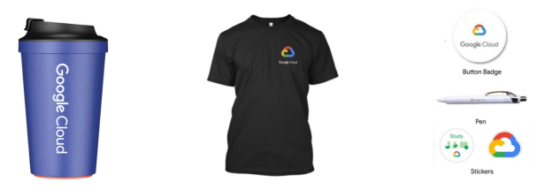

****Milestone 2 Prizes****

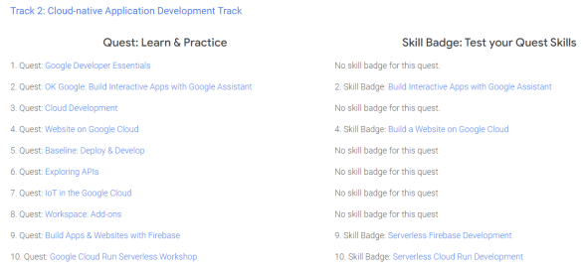

****Milestone 3 → Big Data & Machine Learning Track****

In milestone 3 you need to complete any 30quests and 15 skill badges in the program, As the reward for completing the milestone 3 you will be getting one bag, sling bag, Google cloud t-shirt, Google cloud badge, Google cloud Pen, and Google cloud stickers.

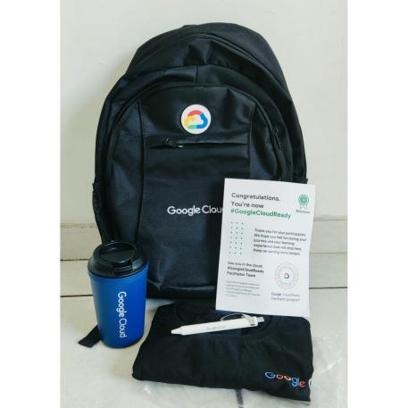

****Milestone 3 Prizes****

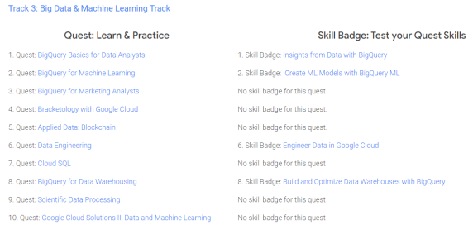

****Milestone 4 → Security, Machine Learning & AI****

In milestone 4 you need to complete any 40 quests and 20 skill badges in the program, As the reward for completing the milestone 4 you will be getting all the rewards of milestone 1 to milestone 3 but along with that you will be able to get free access to the Google Cloud Career Readiness program.



****Milestone 4 Prizes****

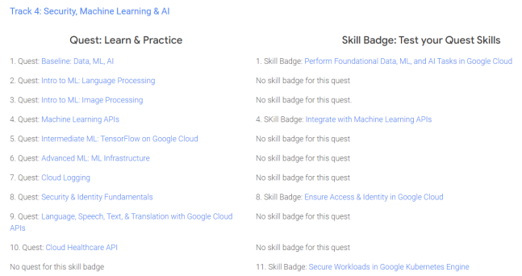

## **FREE access to the Google Cloud Career Readiness program**

Get a chance to grow your career using resources designed to build skills for a cloud-first workplace. The program will provide a chance to achieve industry-recognized credentials.

You can choose from 2 tracks in the program:  
****1. Associate Cloud Engineer track  
2. Data Analyst track.****

You can get to learn more about this program by referring to the below link :

## **[Google Cloud for Education - Career Readiness](https://cloud.google.com/edu/career-readiness" \t "https://medium.com/@misalPav/_blank)**

### [As a faculty facilitator, you will guide your students through the on-demand training, hands-on labs, and certification…](https://cloud.google.com/edu/career-readiness" \t "https://medium.com/@misalPav/_blank)

[cloud.google.com](https://cloud.google.com/edu/career-readiness" \t "https://medium.com/@misalPav/_blank)

# ****_Difference between Quests and badge****

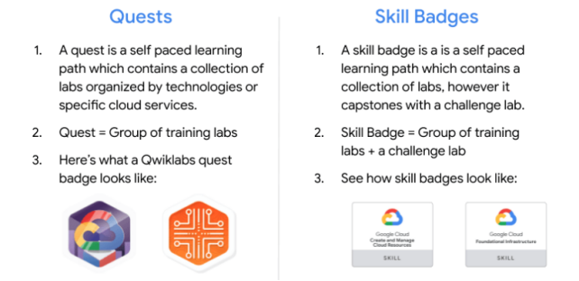

****Remember that you will receive the prizes only for the milestone achieved. If you complete any of the above-mentioned Milestone of the program prizes will be delivered to you within two months after the completion of the program to your address provided by you in the Google form that they will send you on email after the completion of the program.****

Thank you for reading ! Suggestions are welcome!

Do follow for more such blogs!

_Rajani